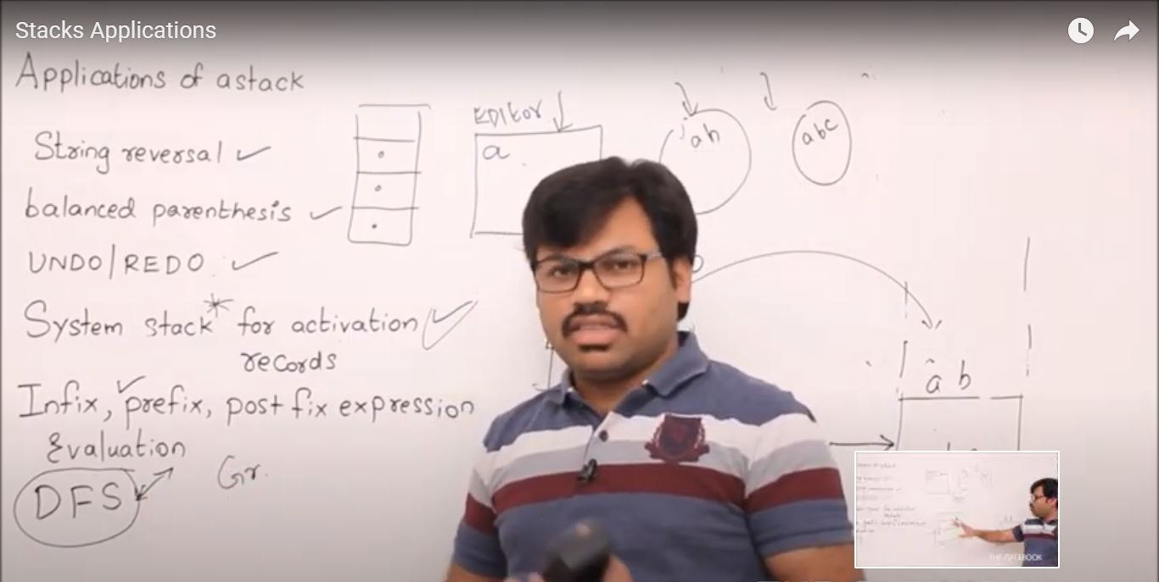

1. For Undo redo functionality in text editor we use of stack.